Supplementary material
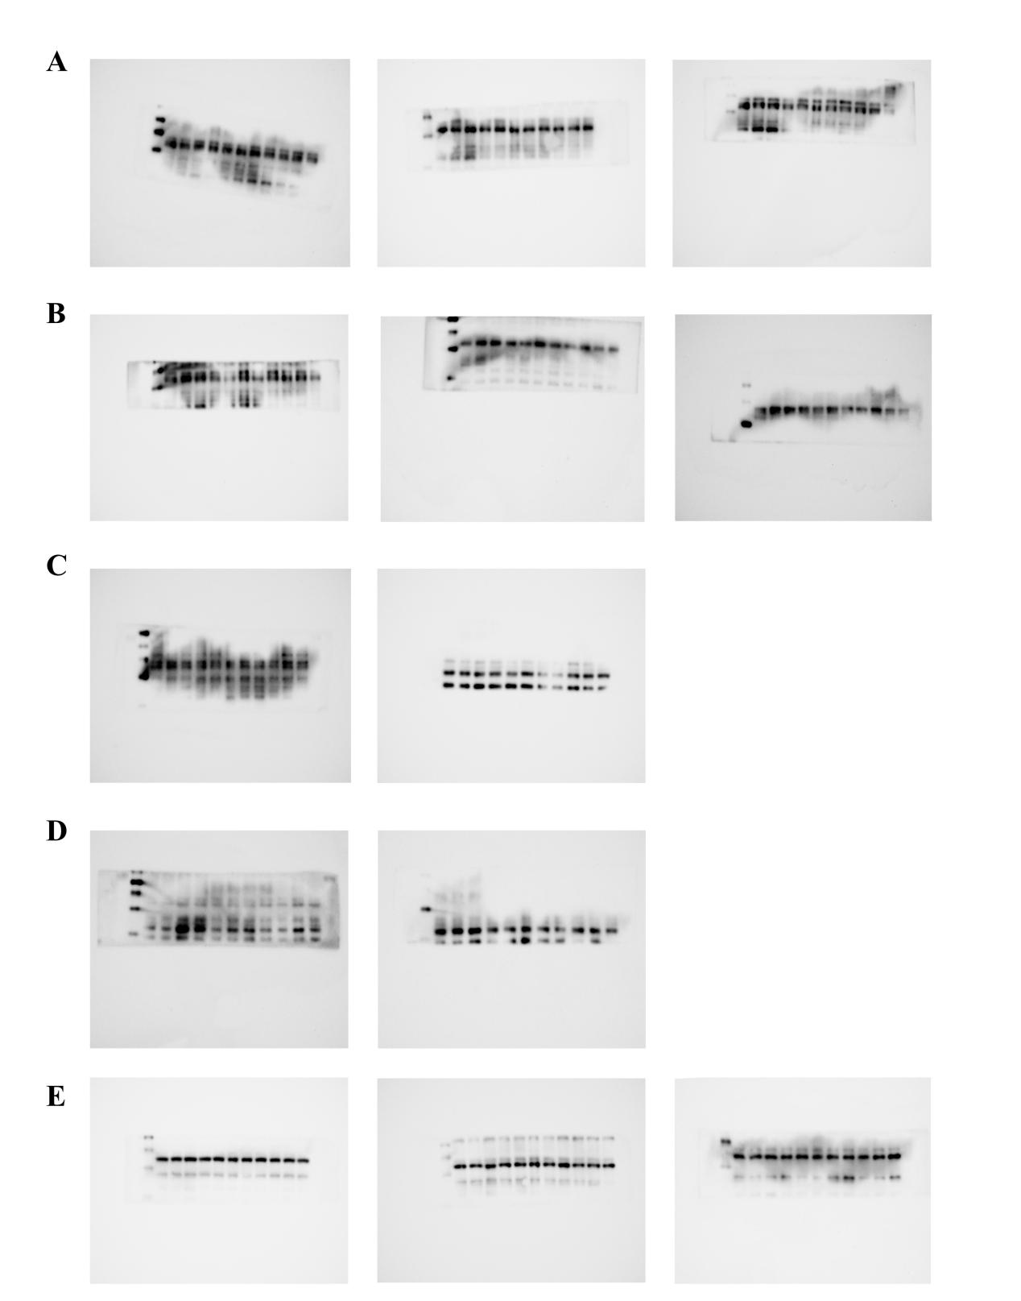

Supplementary Figure.S1 The original Western Blot (WB) images of c-JUN (A), P-c-JUN (B), JNK (C), P-JNK (D), and β-Actin (E) (BV2).

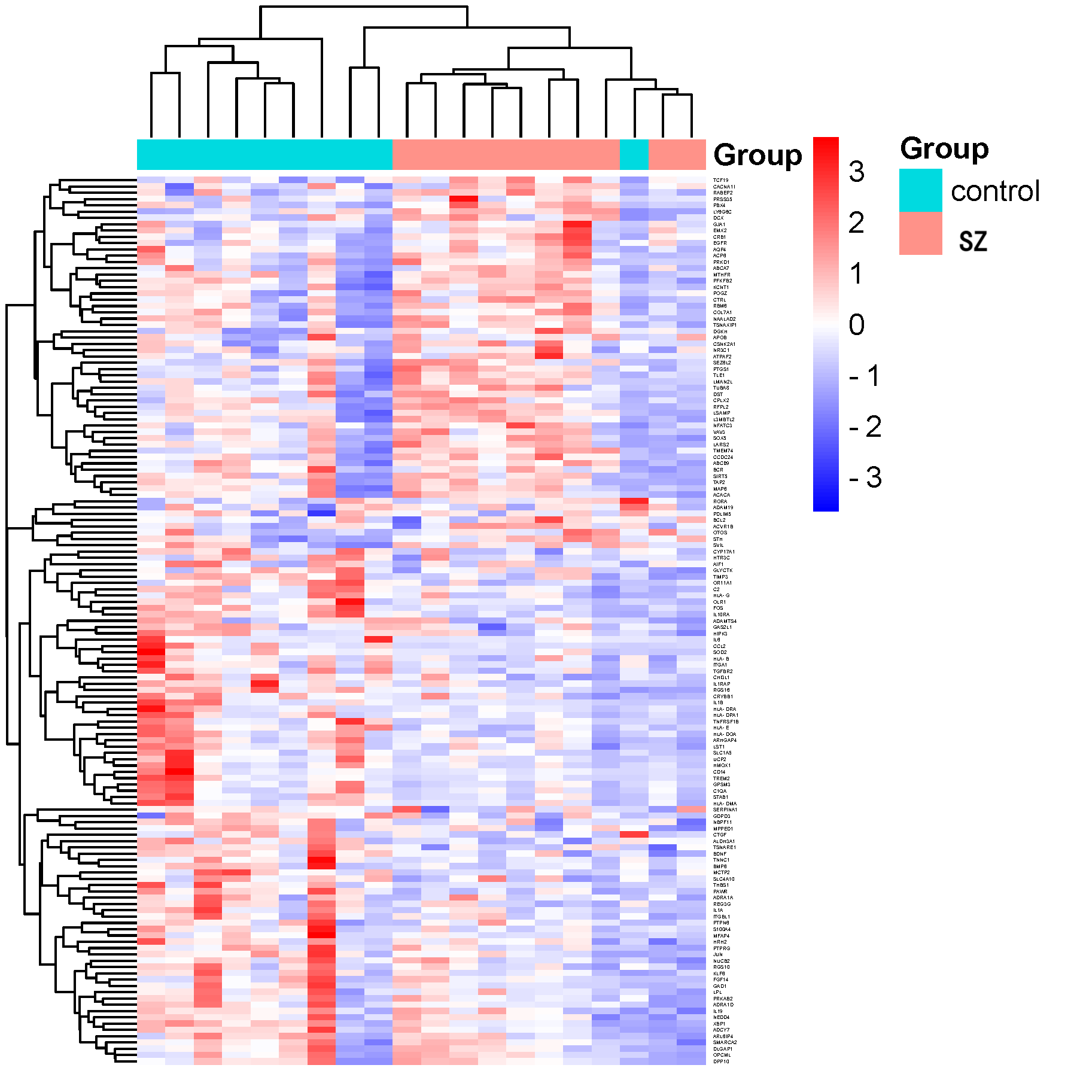

Supplementary Figure.S2 The clustering analysis heatmap of GSE26927.

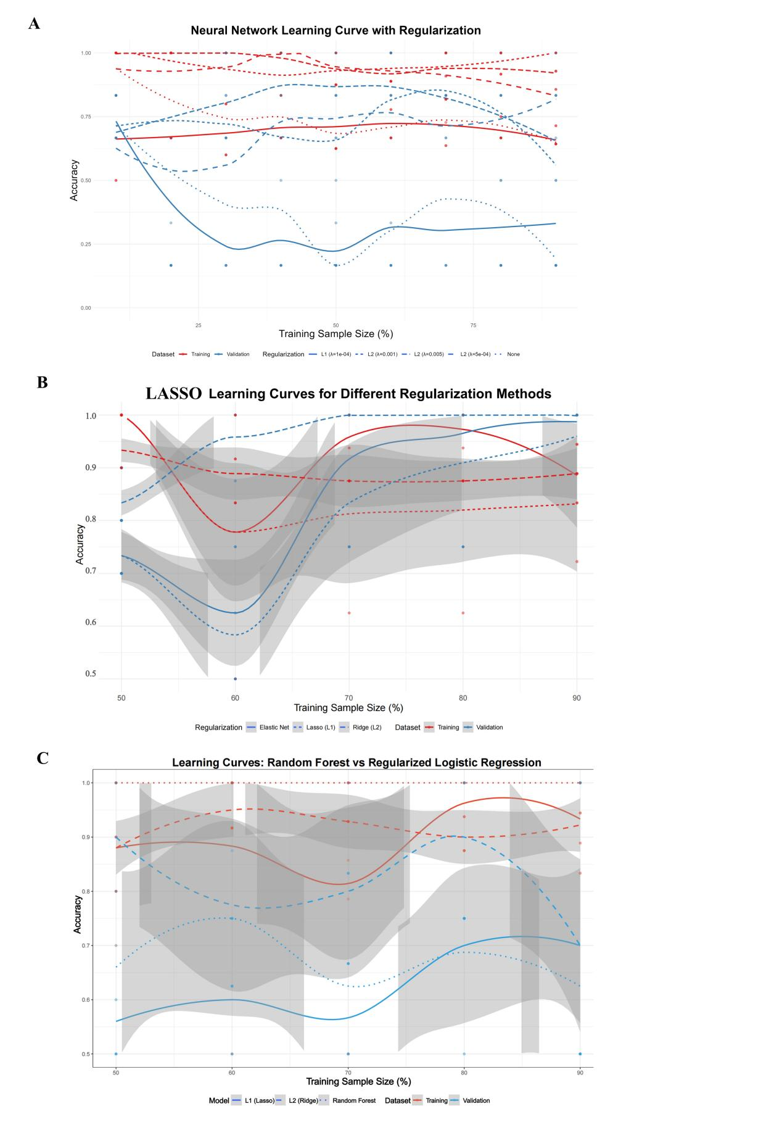
Supplementary Figure.S3 (A) Evaluation Chart of Learning Curves for L1/L2 Regularization in NNET. (B) Evaluation Chart of Learning Curves for L1/L2 Regularization in LASSO. (B) Evaluation Chart of Learning Curves for L1/L2 Regularization in RF.
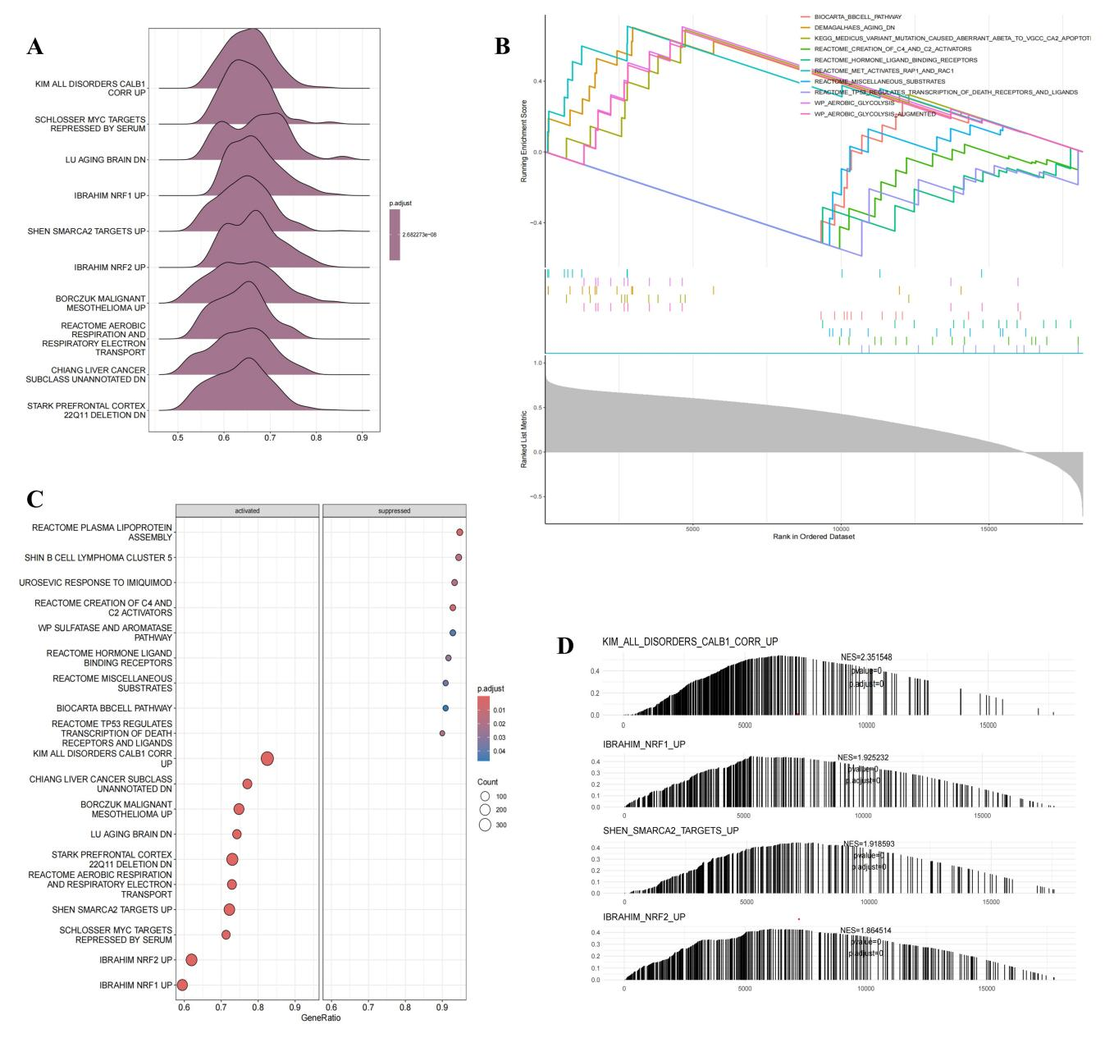
Supplementary Figure.S4 (A) Ridge Plot. (B) The first five and the last five pathways. (C) The classified bubble chart reflects the activated and inhibited pathways. (D) Simplified diagrams of the first three pathways.

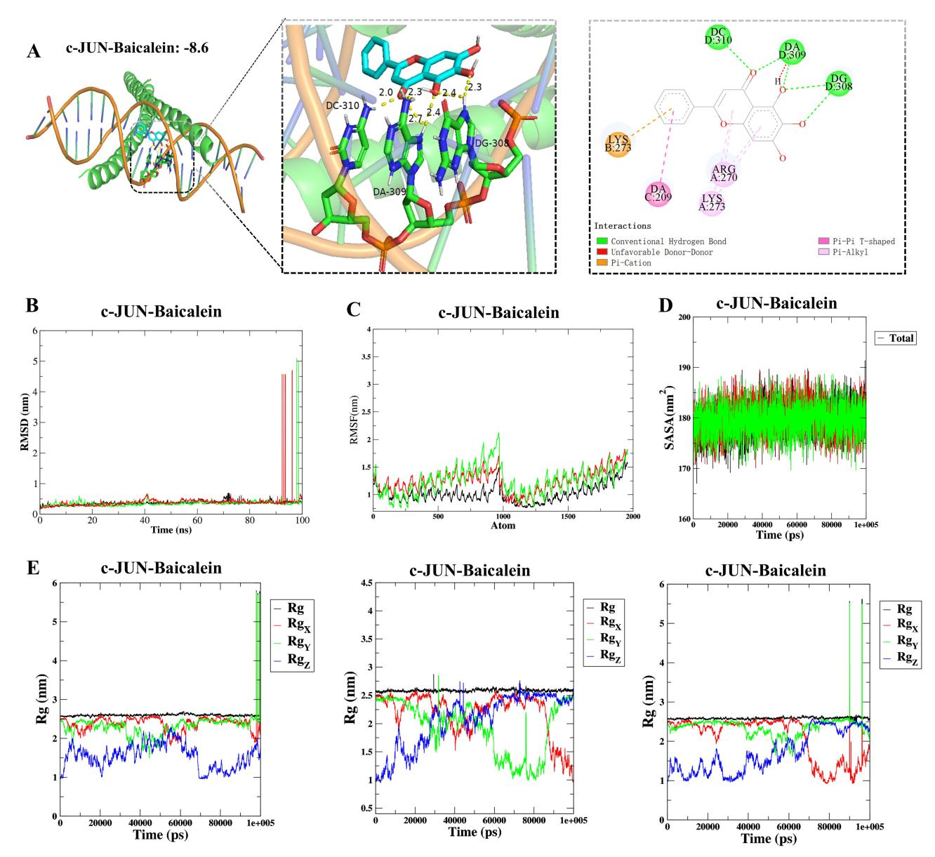

Supplementary Figure.S5 Diagrams of molecular docking and molecular dynamics simulation of baicalein with c-JUN. (A) The baicalein binds to c-JUN through non - covalent interactions such as conventional hydrogen bonds (green dashed lines), π - cation interactions (orange dashed lines), and Pi - Alkyl interactions (pink dashed lines), involving various amino acid residues including DC, DA, LYS, and ARG, thus clarifying the interaction mode between the small - molecule ligand and the protein active pocket. (B) The RMSD curves of c-JUN–Baicalein from three runs. (C) The RMSF curves of c-JUN–Baicalein from three runs. (D) The SASA curves of c-JUN–Baicalein from three runs. (E) The Rg curves of c-JUN–Baicalein from three runs.

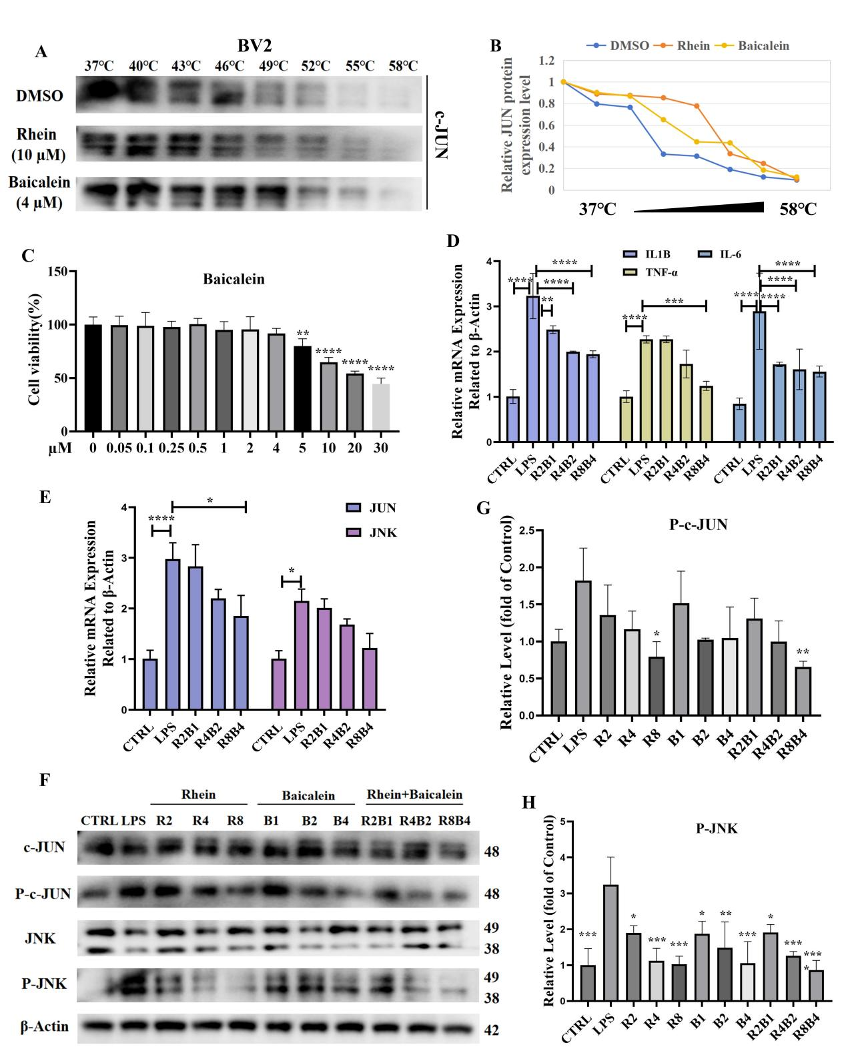

Supplementary Figure.S6 Other treatment groups were established: 1 µM Baicalein (B1), 2 µM Baicalein (B2), 4 µM Baicalein (B4), 2 µM Rhein combined with 1 µM Baicalein (R2B1), 4 µM Rhein with 2 µM Baicalein (R4B2), and 8 µM Rhein with 4 µM Baicalein (R8B4). (A) The immunoblot intensity of c-JUN in BV2 cells in the presence and absence of capsaicin in the CETSA experiments. Representative images are shown. (B) Three independent experiments did quantify the relative intensity of c-JUN protein in the presence and absence of Baicalein and Rhein versus increased temperature. The Baicalein (C) results of CCK-8. *p < 0.05, **p < 0.01, ***p < 0.001, ****p < 0.0001 versus 0 group. (D) and (E) were relative mRNA expression (Related to β-Actin). (F) The results of WB in BV2 cells. (G) and (H) were relative levels of WB. *p < 0.05, **p < 0.01, ***p < 0.001, ****p < 0.0001 versus the LPS group. Each experiment was repeated three times.

Table S1. Coefficients of core genes in LASSO model

 | Gene | Coef
1 | (Intercept) | 1.15648150272402
2 | CYP17A1 | -0.110179625
3 | TNNC1 | -0.109574614
4 | PTGS1 | 0.057712518539759
5 | CSNK2A1 | 0.021259566345752
6 | BCL2 | 0.0194525623722811
7 | EGFR | 0.0106801926914028
8 | JUN | -0.004329476
9 | IL1B | -0.002062639
10 | RORA | -0.002044492
11 | SOD2 | -0.001856741

Table S2. Core genes in SVM model

 | FeatureName | FeatureID | AvgRank
1 | TNNC1 | 15 | 3.6
2 | JUN | 17 | 5.6
3 | PTGS1 | 9 | 6.4
4 | RORA | 1 | 6.6
5 | SOD2 | 6 | 6.8
6 | ADRA1A | 5 | 7
7 | EGFR | 3 | 8
8 | BCL2 | 14 | 8.2
9 | CSNK2A1 | 13 | 8.4
10 | IL1B | 12 | 9
11 | PTPN6 | 10 | 9.2
12 | CYP17A1 | 2 | 9.6
13 | IL6 | 16 | 11.4
14 | NR3C1 | 7 | 12
15 | TGFBR2 | 8 | 12.8
16 | ADRA1D | 4 | 14
17 | CD14 | 11 | 14.4

Table S3. Core genes in RF model

Gene | control | SCZ | Mean Decrease Accuracy | importance
CYP17A1 | 2.8328278085216 | 2.03919709555918 | 2.99700621405189 | 0.982494394902483
IL1B | 1.43085915020539 | 3.67820479827071 | 2.97980093475149 | 0.861844387230417
TNNC1 | 1.28819325090976 | 2.76757556521259 | 2.56468255475636 | 0.806562277591689
JUN | 2.95786398575185 | 1.7871215337771 | 2.35475541790569 | 0.743448210694534
PTPN6 | -1.446376916 | 0.582839043249267 | -0.49745937 | 0.677608030858031
SOD2 | 1.67025131878866 | 1.73937454775413 | 2.0687359749085 | 0.667874560488531
IL6 | 1.49609149559341 | 4.03622011250828 | 3.77198892172162 | 0.62194496924644
TGFBR2 | -0.220779573 | 1.32429559811944 | 0.608917222080412 | 0.578535475961947
EGFR | 1.24955166041109 | 1.30471788949944 | 1.68043291030209 | 0.544686942550913

Table S4. Core genes in NNET model

 | Gene | Importance
1 | EGFR | 15.4000820266937
2 | JUN | 14.0671782772111
3 | RORA | 10.3896369236253
4 | ADRA1D | 8.74441123319665
5 | PTPN6 | 7.26568656872828
6 | CSNK2A1 | 6.21127465429001
7 | SOD2 | 6.0098846199255
8 | TGFBR2 | 5.934484543
9 | CD14 | 4.77145186570423

